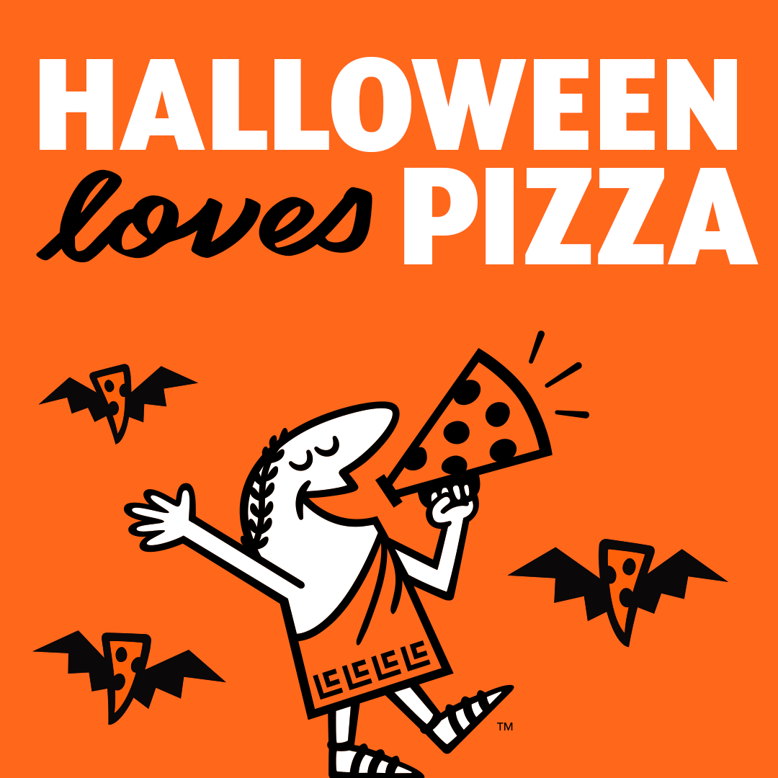
Little Caesar’s arrived on Oct 25th just in time for Halloween!!! We thank everyone for their prompt pick up as well as to all of the fundraising efforts! We made a total of $768.00! School Council purchased 7 kits for our school for students to be able to enjoy free pizza lunches again this year! Thank you School Council members for everything you do and for your generous donation to our students!

School Council Meeting

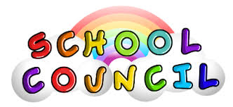

6:00 p.m., Tonight, November 1st

Loving our new math game that helps with Number Sense! Building our knowledge of number representation, addition, subtraction, and problem solving!

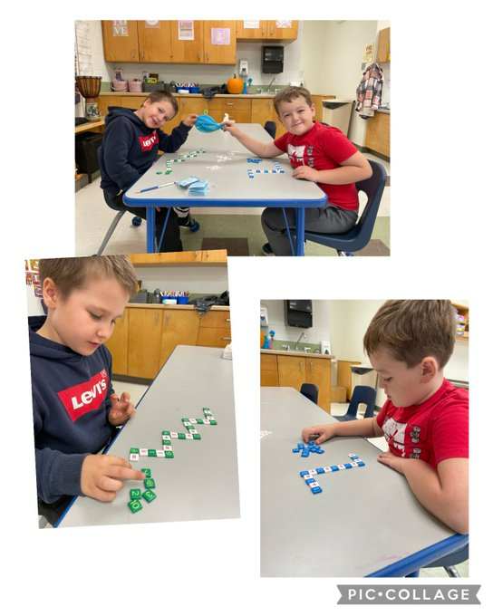

Our Junior/Intermediate students are ready to “rock on” with Ms. LaValley! We are so excited about our new guitars!

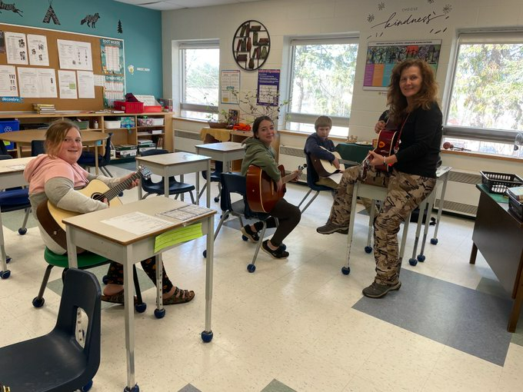

We love our new desks! Thank you to the Algonquin & Lakeshore Catholic District School Board!

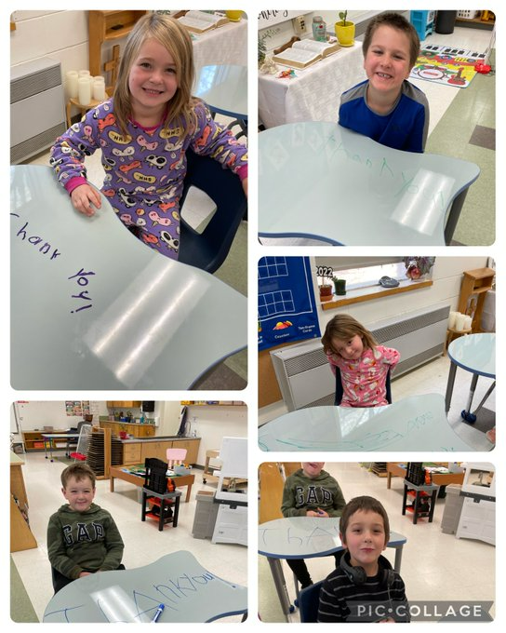
PLEASE JOIN US FOR
MEET THE TEACHER NIGHT AND FAMILY BBQ

WEDNESDAY, NOVEMBER 2nd
4:30 p.m. to 6:30 p.m.

UPCOMING EVENTS

PICTURE RETAKES AND GRAD PHOTOS

FRIDAY, NOVEMBER 4th

REMEMBRANCE DAYS
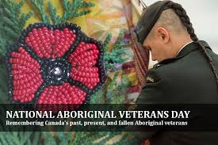
TUESDAY, NOVEMBER 8th

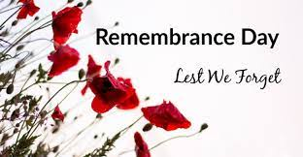
FRIDAY, NOVEMBER 11th
Please arrive at 10:30 a.m.

